COMP-SCI 5560 (SS16) - Knowledge Discovery and Management

Project - Report 1 (Due 06/24/16)

**Architecture of Recommendation System**

*by* ***Dayu Wang*** (Class ID: **45**)

The architecture of our recommendation system is generated based on the following assumptions, which comes from people’s common sense when they are performing a web search.

1. The behavior of the user during the current searching is regarded as the most important reference to let the machine know what he/she wants. For example, if the user chooses to eat in a restaurant that has complimentary Wi-Fi service, then even though a restaurant has a 5-star rating, it will not appear on the top page of the recommendation list if it does not provide free internet access.

2. The recommendation system looks at if any *co-occurrence* appears while it is comparing the user’s search with the restaurants’ stored data. Significant indicators will be computed out that attempt to imitate the user’s taste.

3. In order to satisfy text-based search, mathematical similarity comparing algorithm is underlined in the searching engine which enables the similarity connection amongst those indicator results.

4. The user only searches for a restaurant to eat, not for any other purpose (e.g. business).

The high-level architecture of the recommendation system is shown in Figure 1.

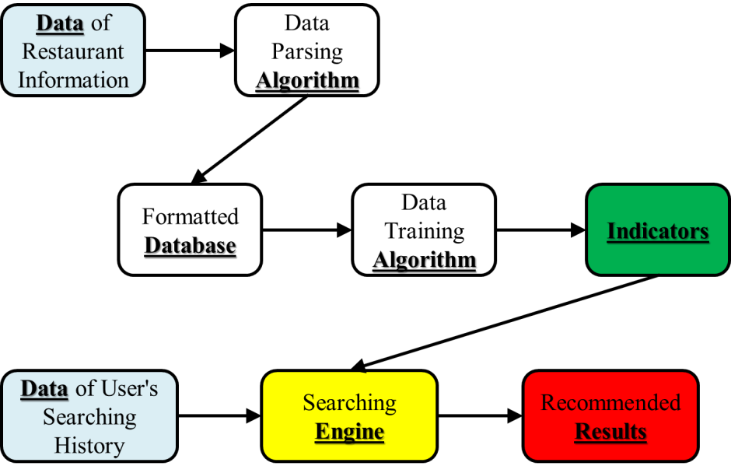

**Figure 1**. High-level architecture of restaurant recommendation system. Arrows indicate the flow direction of data. The black border of each component represents the interface that allows data exchange.

From the architecture in Figure 1, we can see that when the user performs a searching for a restaurant to eat, the recommendation engine generates the recommendation list from mainly two sources of data─restaurant information and user’s searching history. The raw data of restaurants’ information undergoes a process of parsing, and is then transformed to the format (jason format) that will be used in the downstream component. This procedure does not contain data training.

Then, the data is trained using a certain algorithm to create weighted indicators that may be used for recommendation. The indicators will be compared with the user’s searching history to generate the final recommendation list by mathematical similarity comparison.